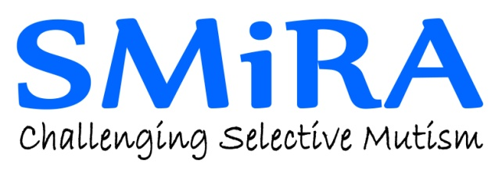
Registered Charity No. 1022673
VAT No. 221 0698 36
www.selectivemutism.org.uk

Co-ordinator:
Mrs Lindsay whittington
5 Keyham Close
Leicester LE5 1FW

Email: info@selectivemutism.org.uk

Charity Gift Aid Declaration
Boost your donation by 25p of Gift Aid for every £1 you donate
Gift Aid is reclaimed by the charity from the tax you pay for the current tax year. Your address is needed to identify you as a current UK taxpayer.
In order to Gift Aid your donation you must tick the box below:

I want to Gift Aid my donation of £__________ to the Selective Mutism Information & Research Association (SMIRA).
I am a UK taxpayer and understand that if I pay less Income Tax and/or Capital Gains Tax in the current tax year than the amount of Gift Aid claimed on all my donations it is my responsibility to pay any difference.

My Details
Title_______________ First name or initial(s)________________________________________
Surname_______________________________________________________________________
Full Home Address________________________________________________________________
_______________________________________________________________________________
_______________________________________________________________________________
Postcode_______________________ Date_________________________________________

Please notify the charity if you:
- Want to cancel this declaration
- Change your name or home address
- No longer pay sufficient tax on your income and/or capital gains

Continued......
If you pay Income Tax at the higher or additional rate and want to receive the additional tax relief due to you, you must include all your Gift Aid donations on your Self-Assessment tax return or ask HM Revenue and Customs to adjust your tax code.

By using this Contact Form you agree to SMIRA storing and using your name, contact and message information to claim Gift Aid on your donation. We won't keep this information for other purposes (eg mailing lists) or pass it to third parties. For more details, please see our Privacy Policy at www.selectivemutism.org.uk
Please tick the box to accept these terms.

Please return your completed form to:
Email: info@selectivemutism.org.uk
or post to the address above

